Please find a selection of recipes for your consideration featuring Steam Whistle Pilsner. Alternatively, please feel free to browse our recipe site http://steamwhistle.ca/fun/recipes.php .
Recipes:
Appetizers
Baby Arugula and goat cheese salad with Steam Whistle Vinaigrette
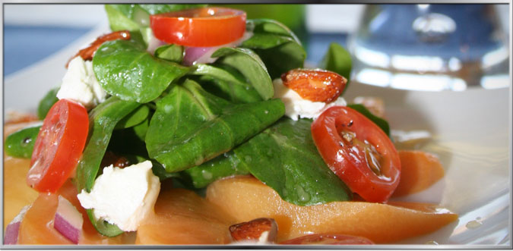
Steam Whistle vinaigrette can be paired with many of your summer salads. Submitted by Melanie Levac from Kingston Campus of Liaison College.
Servings: 8
Ingredients:
Vinaigrette
- 1 bottle (341 ml) Steam Whistle Pilsner
- ¾ cups (180 ml) vegetable oil
- ½ tbsp. (7.5 ml) lemon juice
- 1 tsp. (3 ml) lemon zest
- 1 tsp. (3 ml) Dijon Mustard
- 1.5 tbsp. (22.5 ml) Honey
- Salt and Pepper to taste
Salad
- 4 cups baby arugula
- 4 ripened peaches
- ¼ cup (60 ml ) cheery or grape tomatoes
- 1/8 cup (30 ml) finely diced red onions
- Goat cheese crumbled ( to preference)
Directions:
Vinaigrette
- Slowly reduce the beer to ¼ cup ( 60ml) and let cool in separate bowl
- Add lemon juice, lemon zest, Dijon mustard and honey and whisk together.
- Slowly drizzle with oil and salt and pepper to taste
Salad
- Pit peaches and cut into half-moons and cut tomatoes into halves
- Toss red onions, peaches and arugula with dressing to shine the leaves
- Place on place with tomatoes on top, sprinkle goat cheese, season to taste and drizzle more dressing.
#2 Steam Whistle Cheese Dip
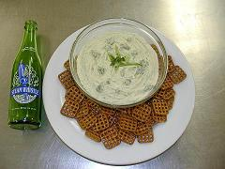
Great for pairing with pretzels or general dip. Recipe created by Chef Carol, Liaison College in Toronto.
Ingredients:
- 2 cups (500 ml) old cheddar cheese, shredded
- 5 tbsp. (75 ml) blue cheese
- 1 tbsp. (15 ml) softened butter
- 3-4 scallions, chopped
- ½ tsp (3.5 ml) dry mustard
- 1.4 tsp (1.5 ml) Tabasco sauce
- 1 tsp (15 ml) Worcestershire sauce
- 2/3 (85 ml) Steam Whistle Pilsner
Directions:
- Combine cheese, butter, scallions, mustard, Tobasco and Worcestershire in food processor and process lightly.
- Add beer to make consistently smooth.
- Garnish with additional scallions or crumbled blue cheese.
- Serve with choice of pretzels or other dipping sidekicks.

#3: Steam Whistle Killer BBQ Sauce
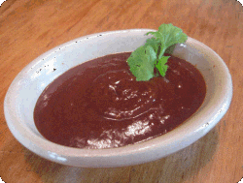
Created by Steve Adams, Team Cedar Grilling
Ingredients:
- 1 bottle (341 ml) Steam Whistle Pilsner
- 2 cups (500 ml) Heinz Ketchup
- ¼ cup (60 ml) brown sugar
- ¼ cup (60 ml) white vinegar
- 3 tbsp. (45 ml) honey
- 2 tsp (6 ml) Worcestershire sauce
- 1 tsp (3 ml) chili powder
- 1 tsp (3 ml) dried mustard
- 1 tsp (3 ml) onion powder
- 1 tsp (3 ml) garlic powder
- ½ tsp (1.5 ml) fresh ground pepper
- ½ tsp ( 1.5 ml) ground coriander seed
- ¼ tsp (1.5 ml) cinnamon
- ¼ tsp. ground allspice
- ¼ tsp cayenne pepper
Directions:
- Add all ingredients into a medium sized pot
- Bring mixture to a boil stirring constantly
- Simmer until slightly thick ( approx. 20 mins)
- Refrigerate unused sauce
Dinner
#1 Steam Whistle Marinated Alberta Beef Flank Steak
Servings: 4-6
Ingredients:
- 2-3 lbs (908-1362 g) Alberta Beef flank steak or “London Broil”
- 2 tbsp. (30 ml) Balsamic Vinegar
- 1 bottle (341m) Steam Whistle Pilsner
- 1 tbsp. (15 ml) Worcestershire sauce
- 2 tbsp. (30 ml) finely minced fresh garlic
- 1 bay leaf
- ½ tsp. (3 ml) dried oregano
- ½ tsp. (3 ml) dried basil
- ½ tsp. (3 ml) dried thyme
- 1 tsp. ( 5 ml) smoked paprika or paprika
- ¼ cup ( 60 ml) olive oil
Directions:
- Combine balsamic vinegar, Steam Whistle Pilsner, Dijon, Worcestershire sauce, garlic, and herbs and whisk in olive oil
- Trim the visible fat off the flank steak and make small scores on both sides of the steak (1/4 inch (1 cm) deep and 1/4 inch (1 cm) apart). This allows for marinade to better penetrate. Pour marinade mixture over meat in a dish, cover and refrigerate for 8-24 hours.
- Drain off marinade and let meet come down to room temperature. Turn grill to medium-high or let coals cool down before you put the meat on. If using a meat thermometer, cook to a temperature to 130^{F} or 55^{C}. Turn the meat after about 6 minutes. Cooking time varies based on temperature and size of steak. Meat will continue to cook as its rests so best to remove underdone versus overdone.
- Let meat rest for 5-15 minutes, cut into thin slices across the grain & serve with your favourite side (grilled veggies or potato) and a cold bottle of Steam Whistle Pilsner.
#2 BBQ Steam Whistle Steak
This is a fast and delicious, creole-inspired recipe great for any summer BBQ. Tested in Harald Sowade’s kitchen.
Ingredients:
- 2 t-bone steaks ( 1 inch thick)
- ½ tbsp. (7.5 ml) minced garlic ( or to taste)
- 1 bottle ( 341 ml) Steam Whistle Pilsner
- 1/3 cup ( 85 ml) olive oil
- 2 tbsp. (30 ml) honey
- 1 tbsp. (15 ml) salt
- ¾ tsp. (4ml) black pepper
- 4 cloves
Directions:
- Sprinkle finely minced garlic onto steak
- Combine beer, olive oil, honey, salt & pepper, and cloves in a flat dish
- Place steaks on dish and marinate in fridge for 12 hours ( turning occasionally)
- Cook steaks on grill while brushing the exposed side with marinade juices ( flip)
- Serve with a cold Steam Whistle Pilsner

Desserts
#1 Steam Whistle Cocktail
If mom’s been doing all the cooking, she can cool off with a refreshing cocktail. This recipe was created by retired Brew Master Harald Sowade.
Ingredients:
- 1 oz. (30 ml) fresh lemon juice
- 2 bottle (682 ml) Steam Whistle Pilsner
- Pinch of ginger
- Cinnamon bark
Directions:
- Boil the beer, pinch of ginger and the cinnamon bark for 3 minutes.
- Pour in the lemon juice and continue to boil for 1 minute longer.
- Pass through a fine sieve and refrigerate for at least 2 hours.
- Serve iced.
#2 Steam Whistle Granita
Recipe created by Chef Tanya Skeates of The Manx Pub in Ottawa
Serving: 4-6 people
Ingredients:
- 2 cups (500 ml) water
- 1 cup (250 ml) granulated sugar
- 1 ½ cups (375 ml) Steam Whistle Pilsner
- 1 sprig fresh mint
Directions:
- In a stainless steel saucepan, combine all ingredients and bring to a boil.
- Cool mixture by placing saucepan in sink with 1 inch cold water and let cool.
- Pour cooled mixture into plastic ice cube trays
- When ready to serve, empty ice cubes into food processor and mix until smooth and slushy.
- Serve immediately with fresh fruit or biscuits.
- Notes: A successful granite should have a “slush” like consistency. Granite contains alcohol and tends to melt quickly.

